Julien HASSOUN Jonathan EL-BAZ

Cloud an Big Data – Project

1. **NETWORK CONFIGURATION**

**Schema:**

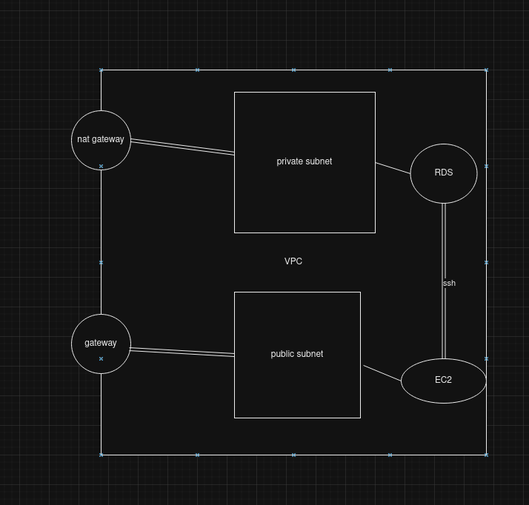

1. **VPC Configuration**

**IPV4 CIDR :** 10.0.0.0/24

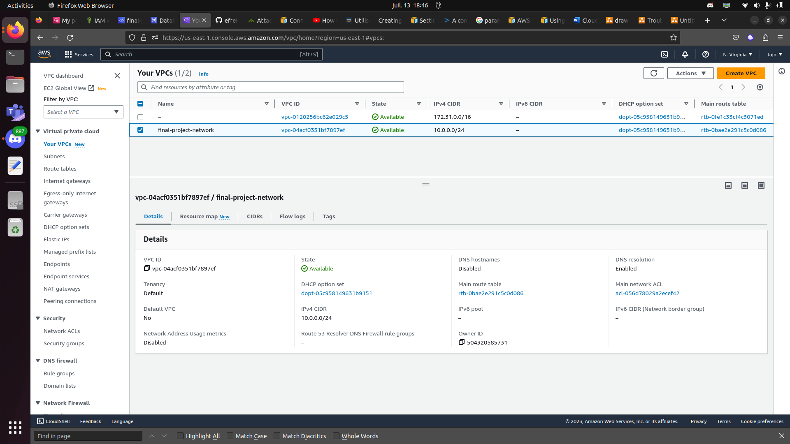

1. **Public subnet configuration**

**IPV4 CIDR: IPV4 CIDR :** 10.0.0.0/25

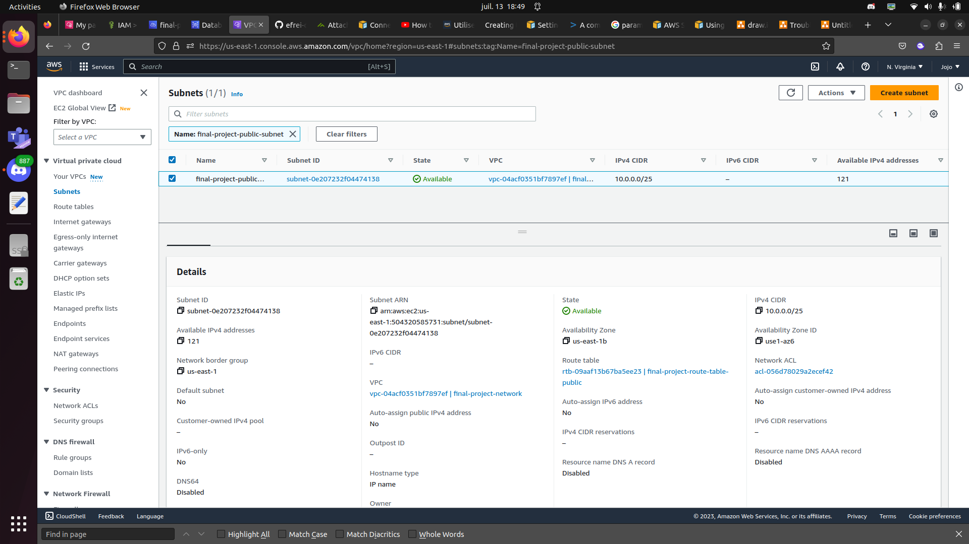

Internet gateway:

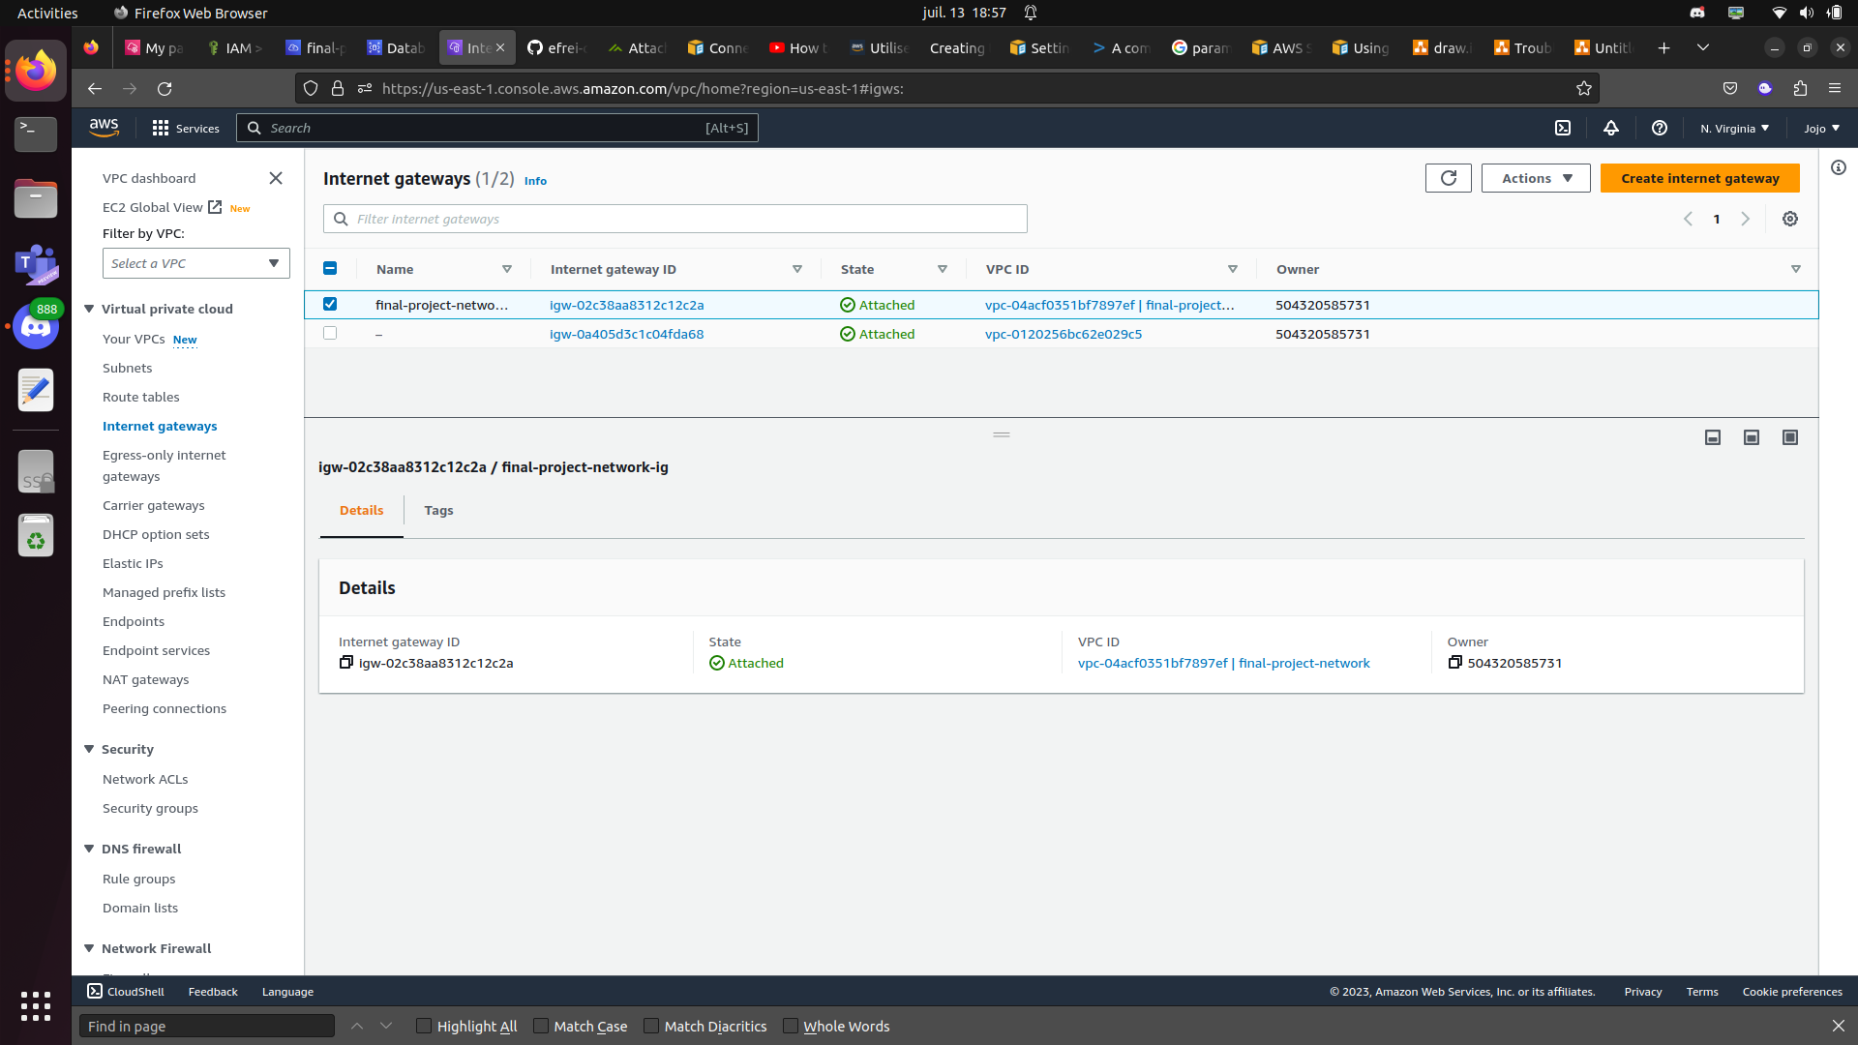

Route table for public subnet :

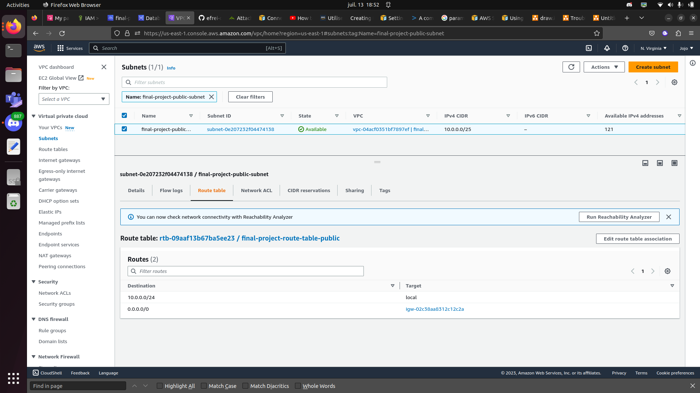

1. **Private subnet configuration**

IPV4 CIDR: 10.0.0.128/25

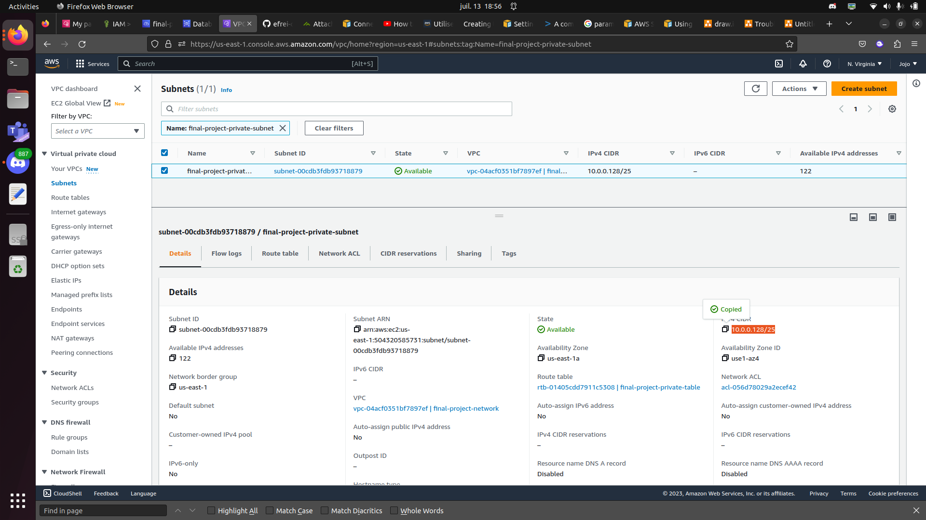

Nat gateway:

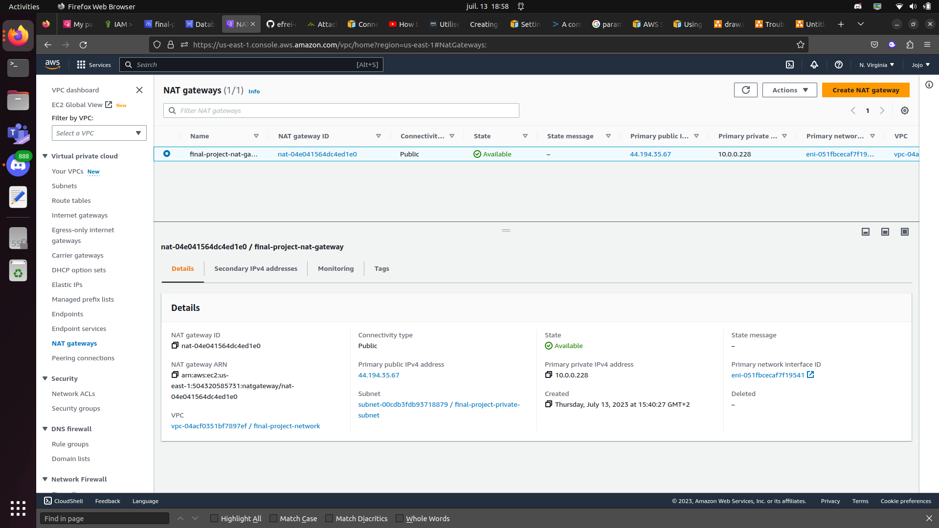

Route table for private subnet:

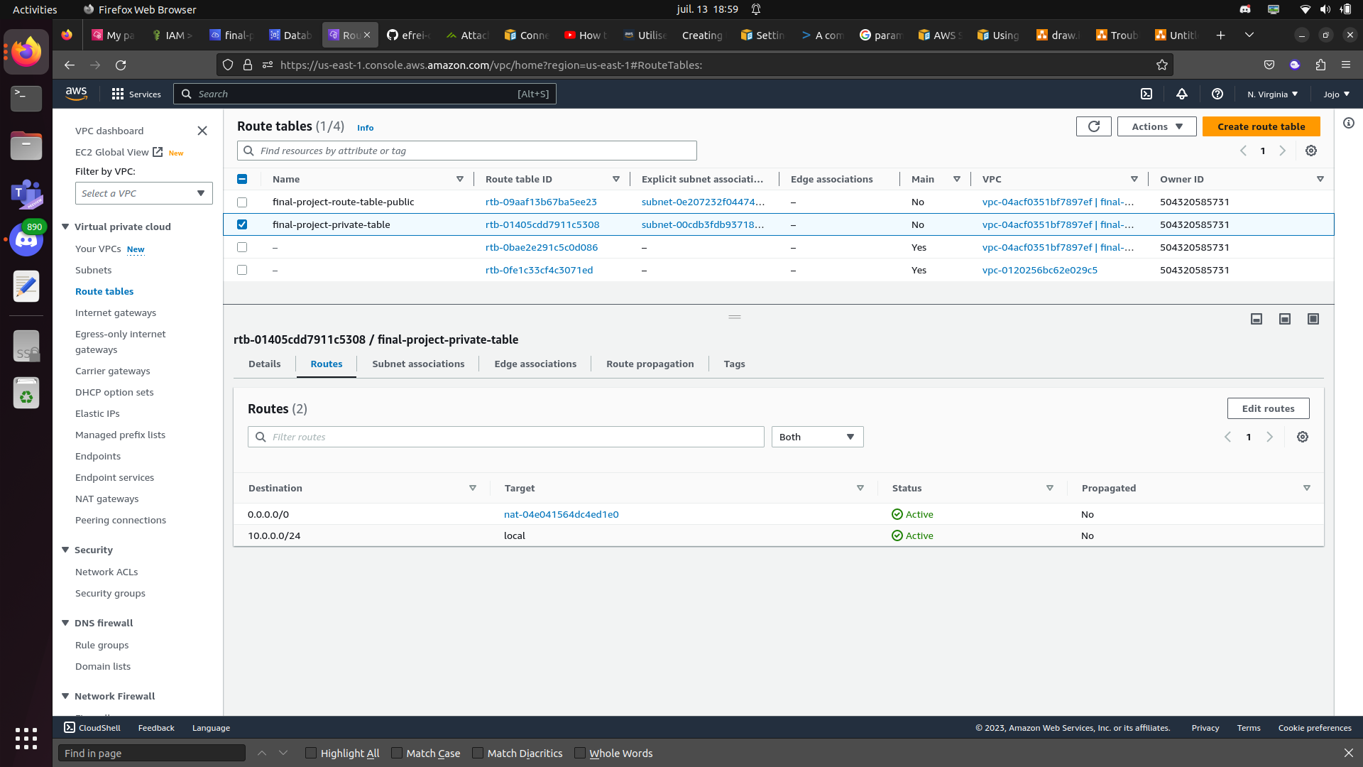

subnet association :

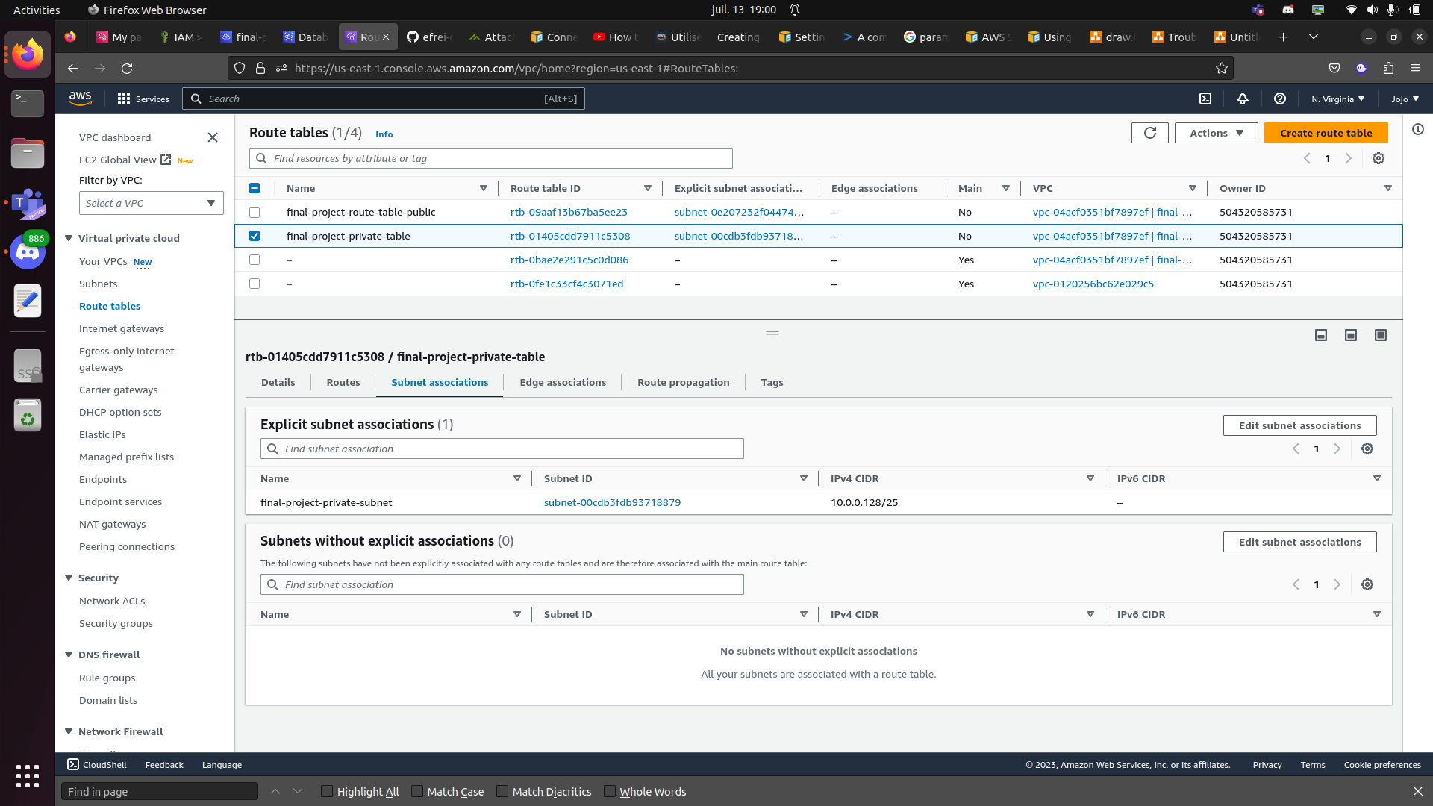

1. **Final Project hosting**
2. **EC2 configuration**

Vpc: final-project-network

Subnet: final-project-public-subnet

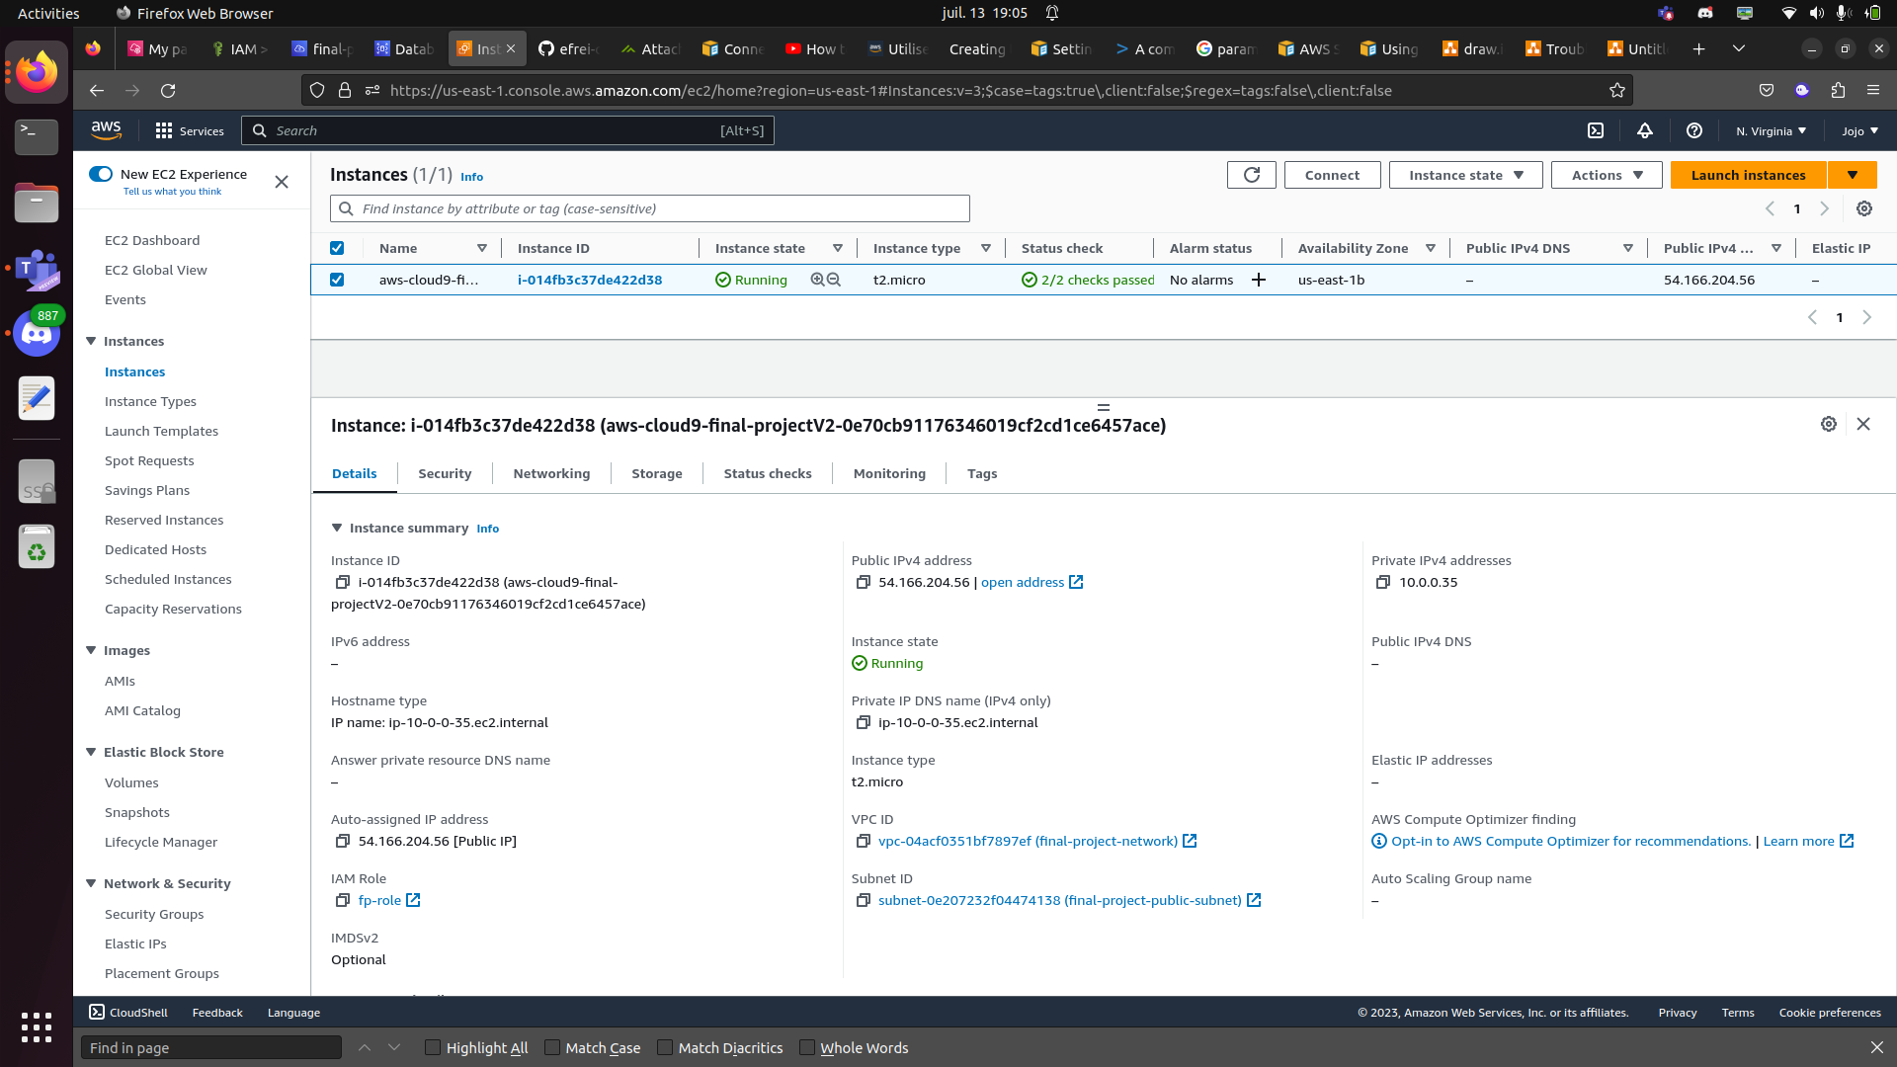

Security group:

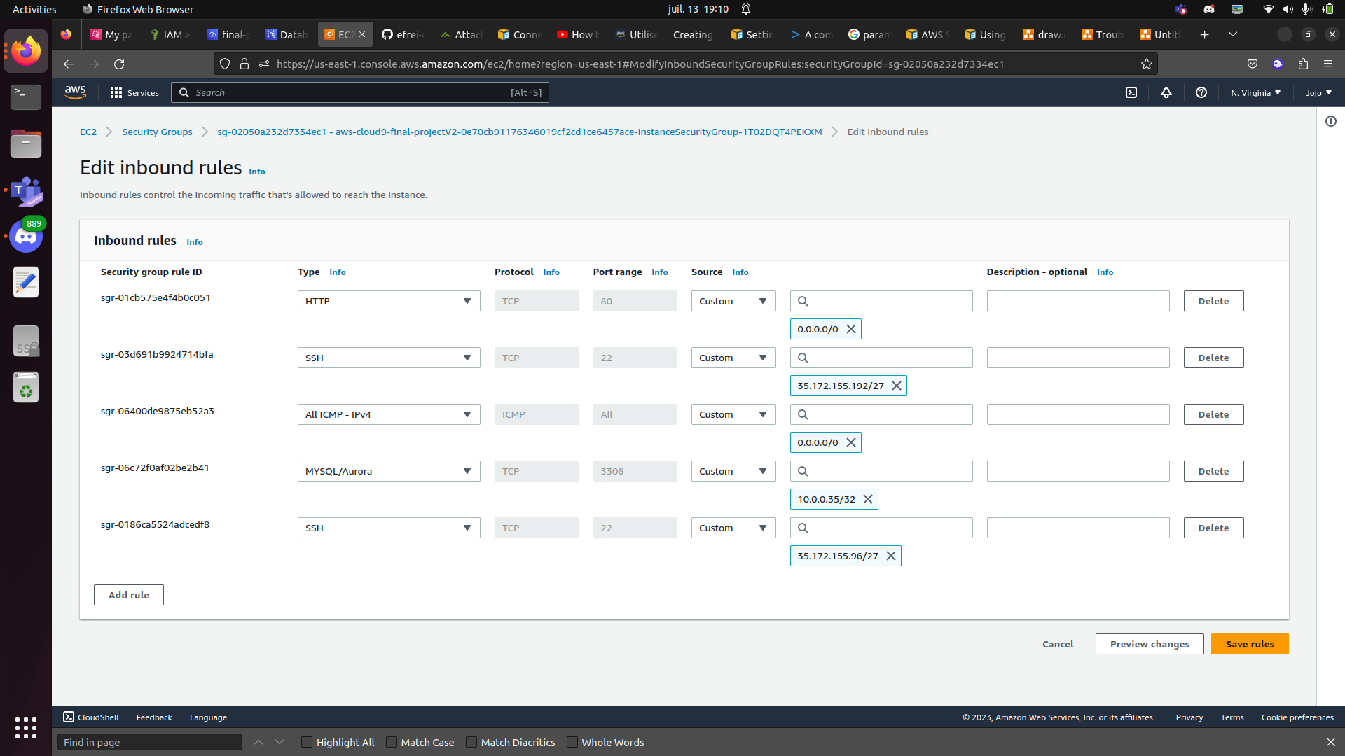

Tesing connection to ec2 instance using public ip:

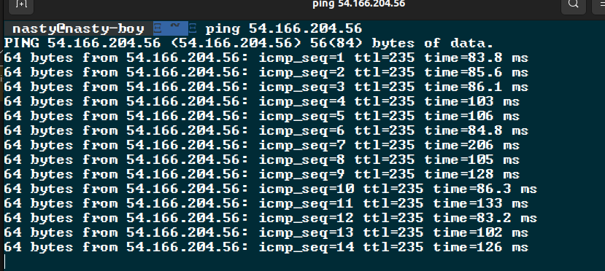

Put PHP app inside ec2 instance using cloud9 and verify http service :

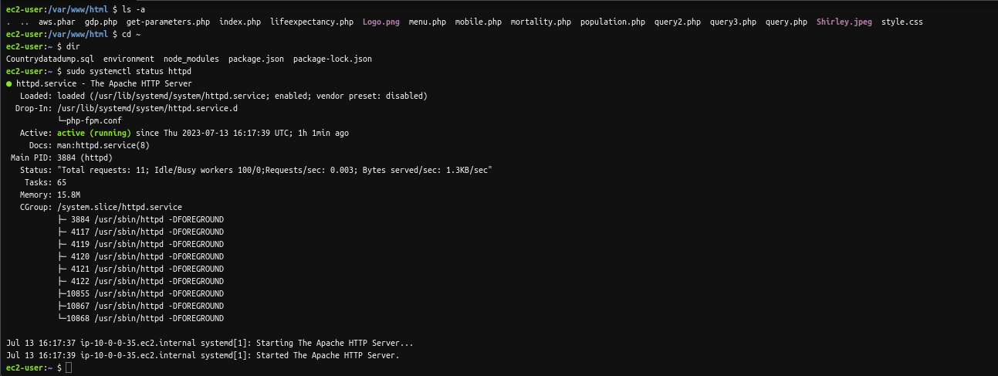

Access to website (PS: my livebox does not allow non https trafic, so, I use my phone to access app with 4g, here is the result)

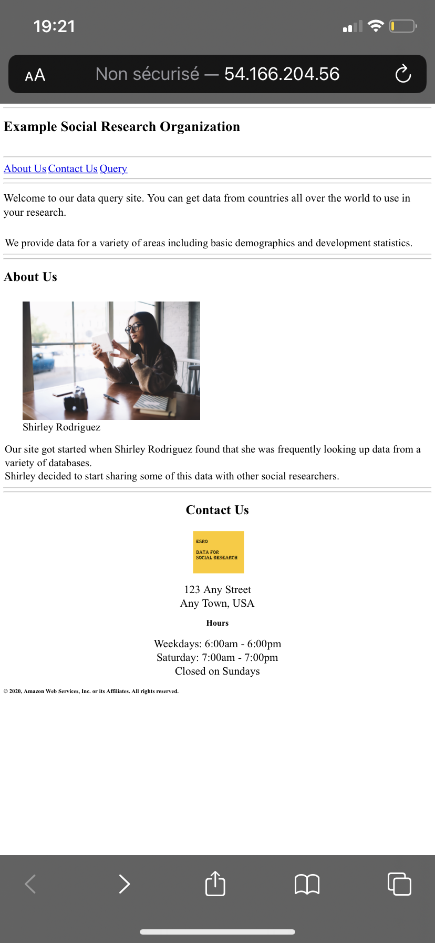

1. **RDS Configuration**

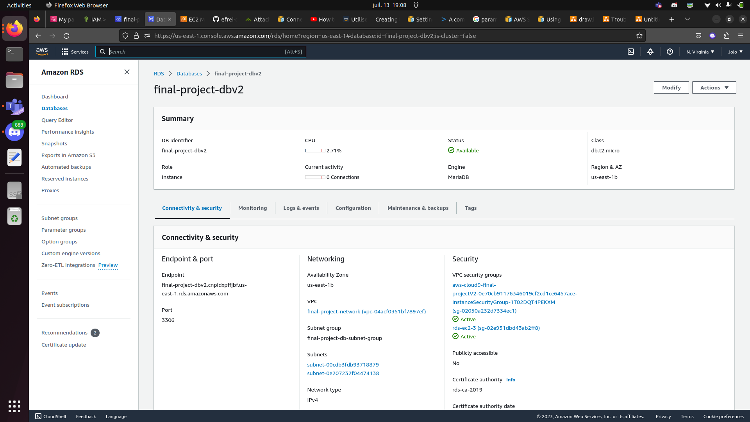

Testing connection to rds inside ec2 instance:

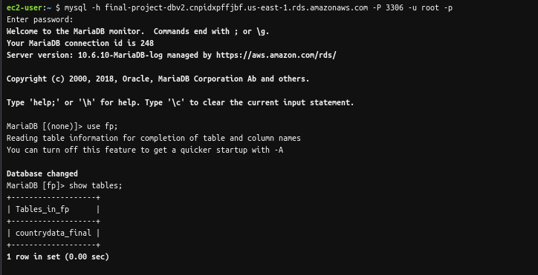

PS : The database fp has been created with “CREATE DATABASE fp;” and the sql file has been dump with “source Countrydatadump.sql”

1. **Parameter store and IAM role**

Parameter store configuration:

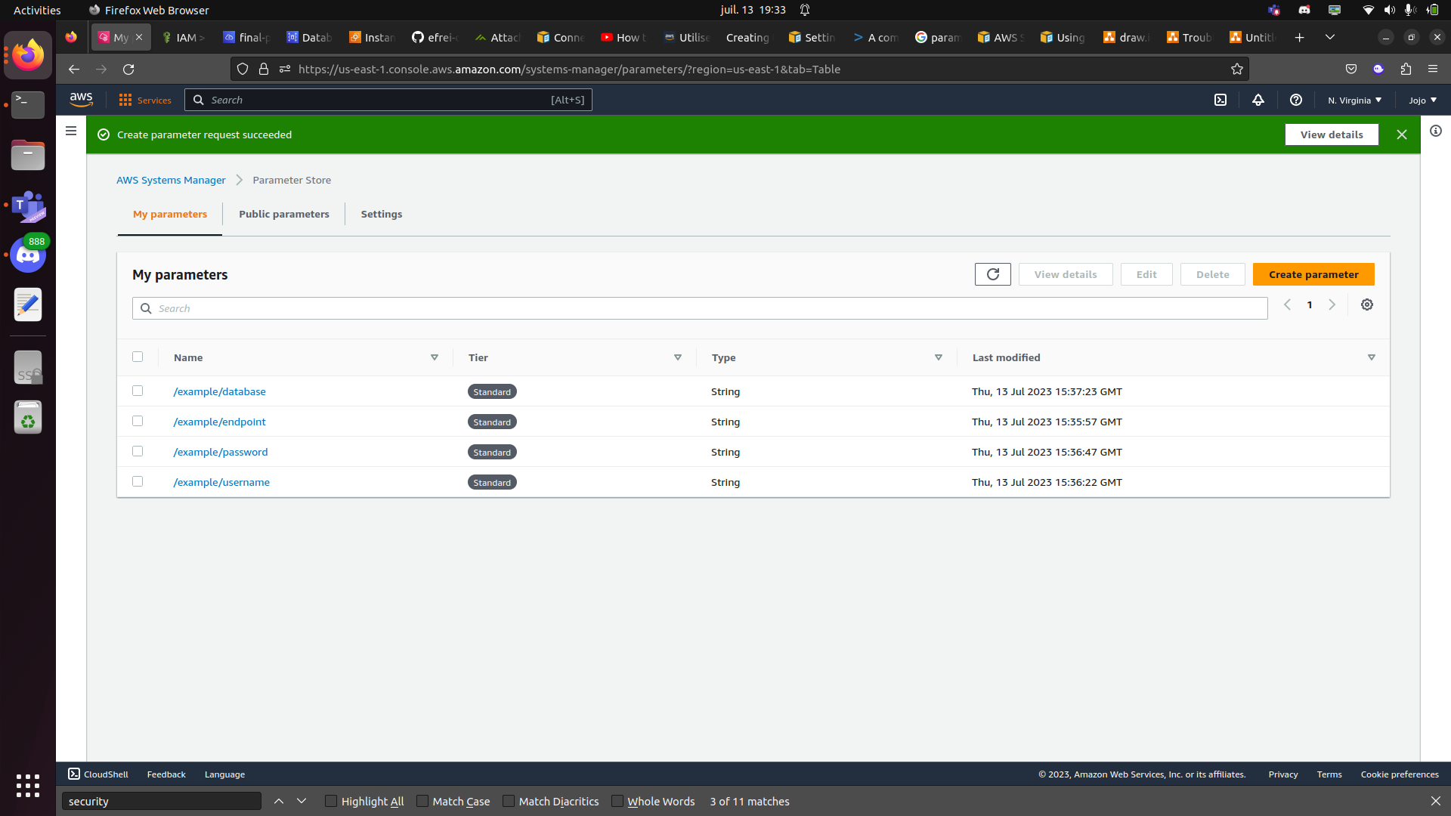

/example/database -> fp (the name of database)

/example/endpoint -> final-project-dbv2.cnpidxpffjbf.us-east-1.rds.amazonaws.com ( the endpoint of rds)

/example/password -> ******** ( the password of database)

/example/username -> root (the username root to access database)

The last step is to let final-project ec2 instance access these parameters store using IAM Roles:

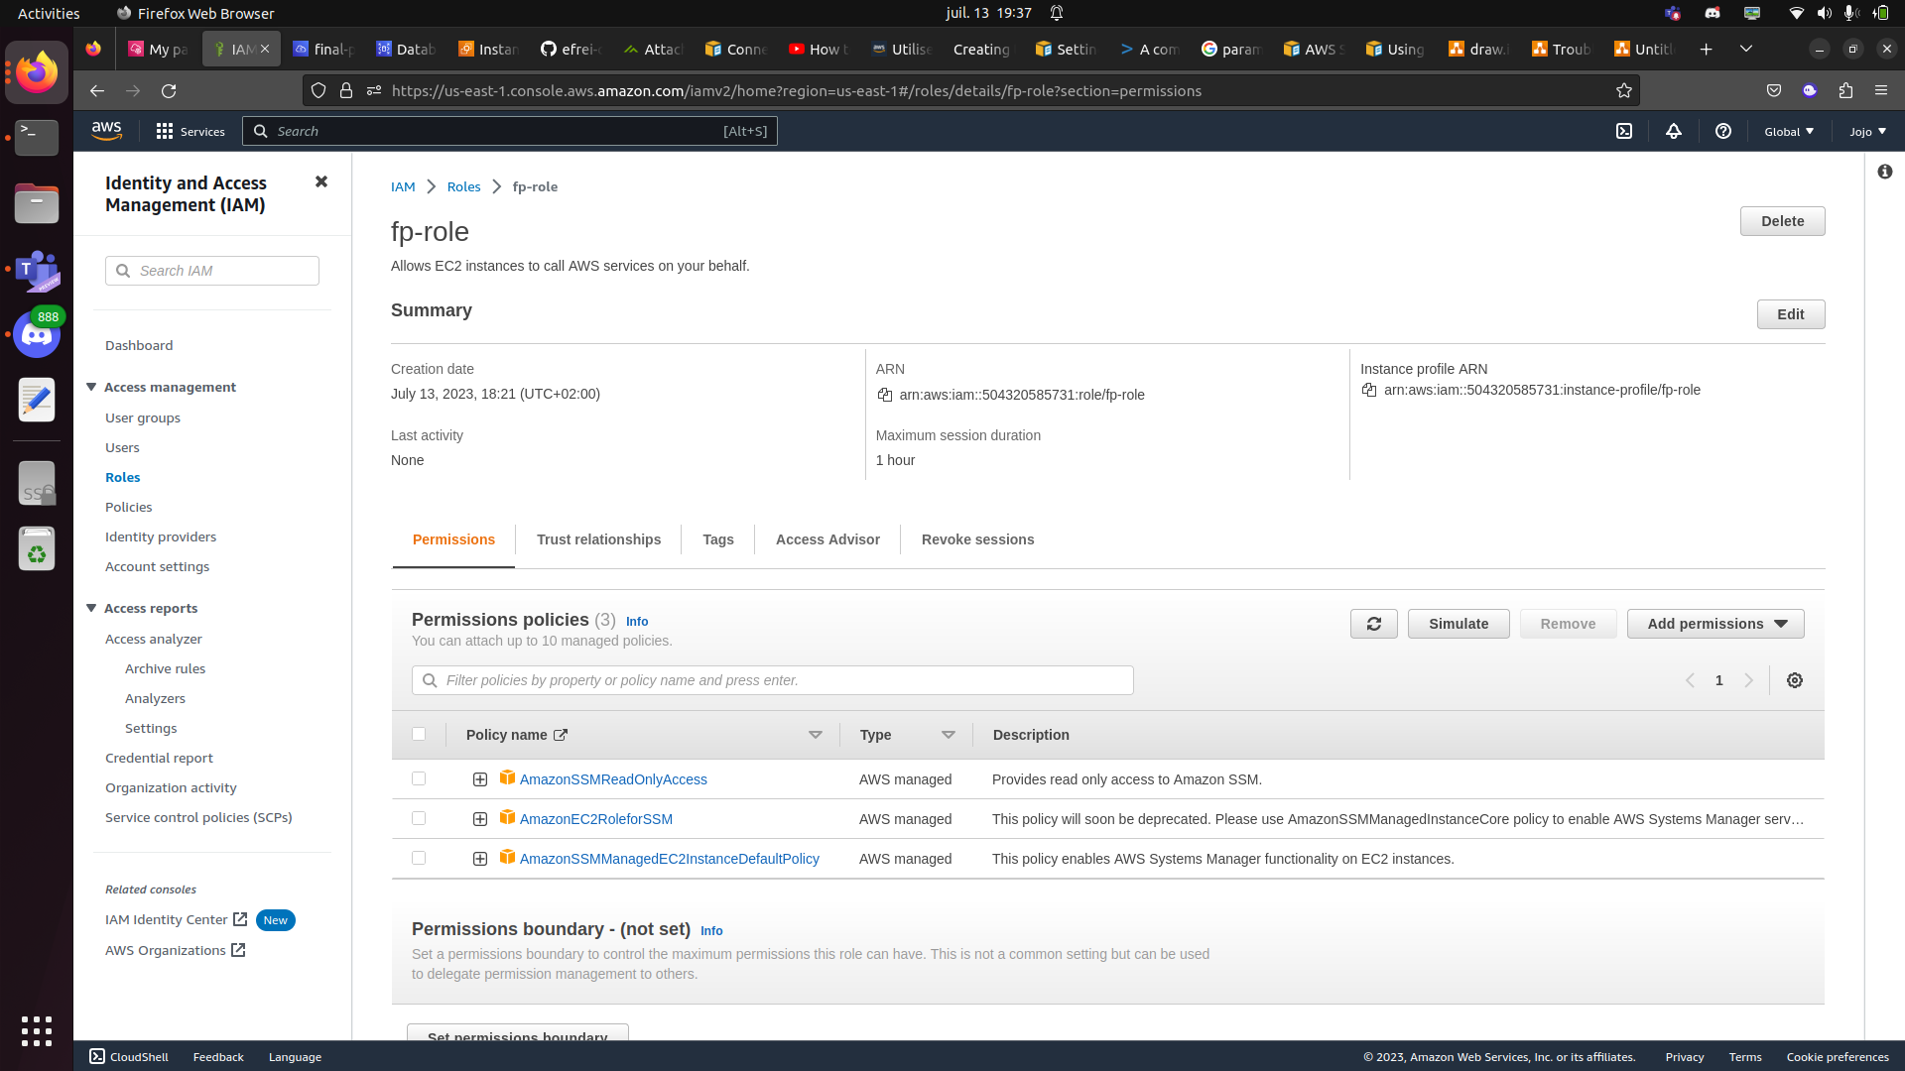

Finally, we assign fp-role to ec2 instance and we can check the website that query correctly the database

Query mobile phone:

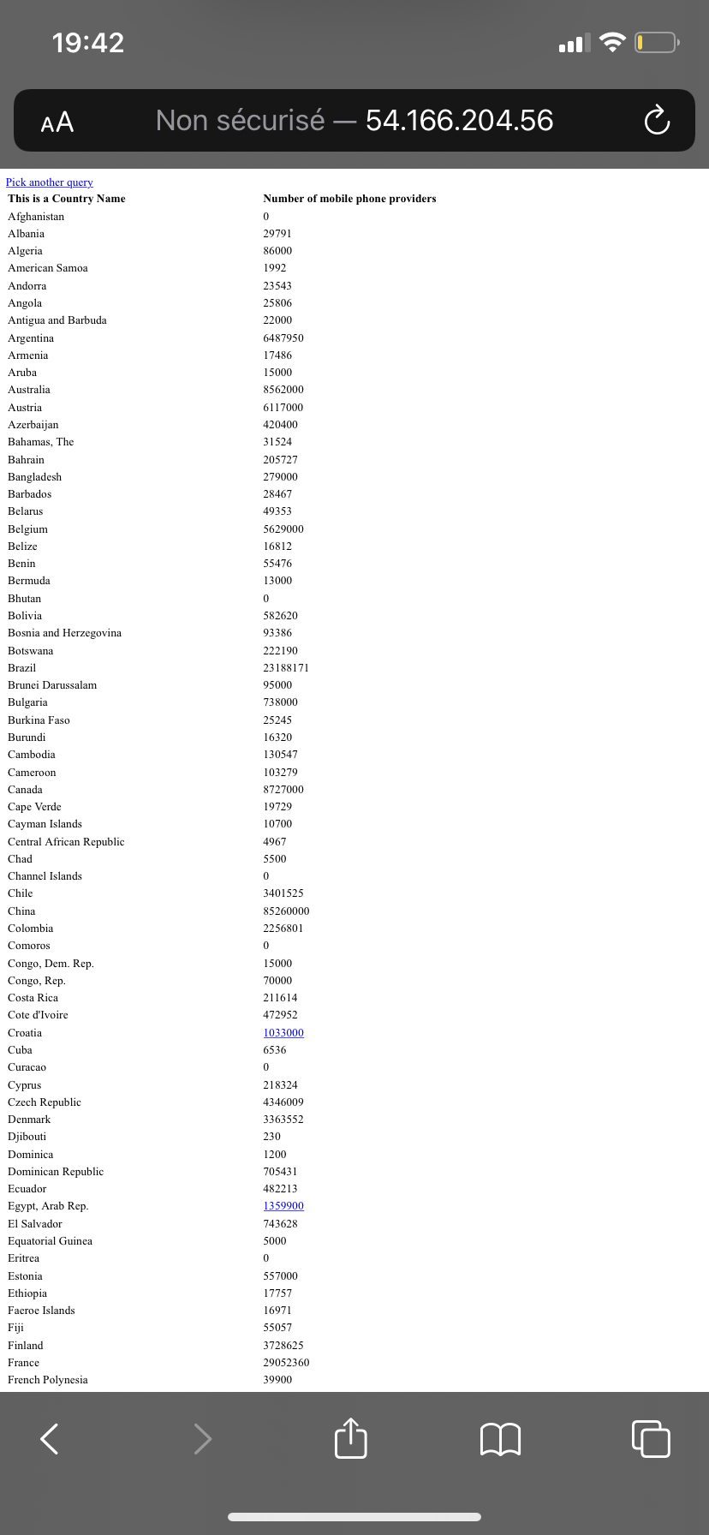

Query population :

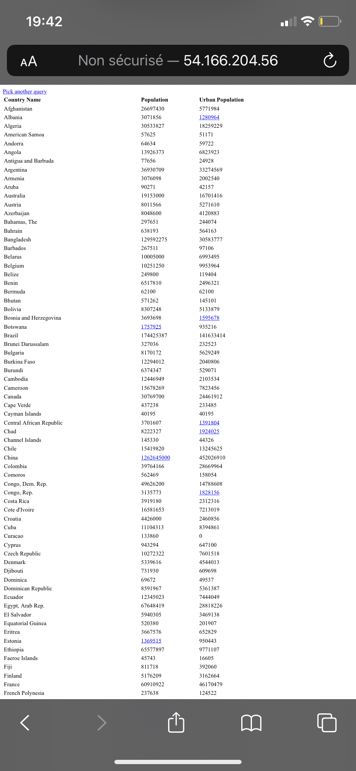

Query life expectency :

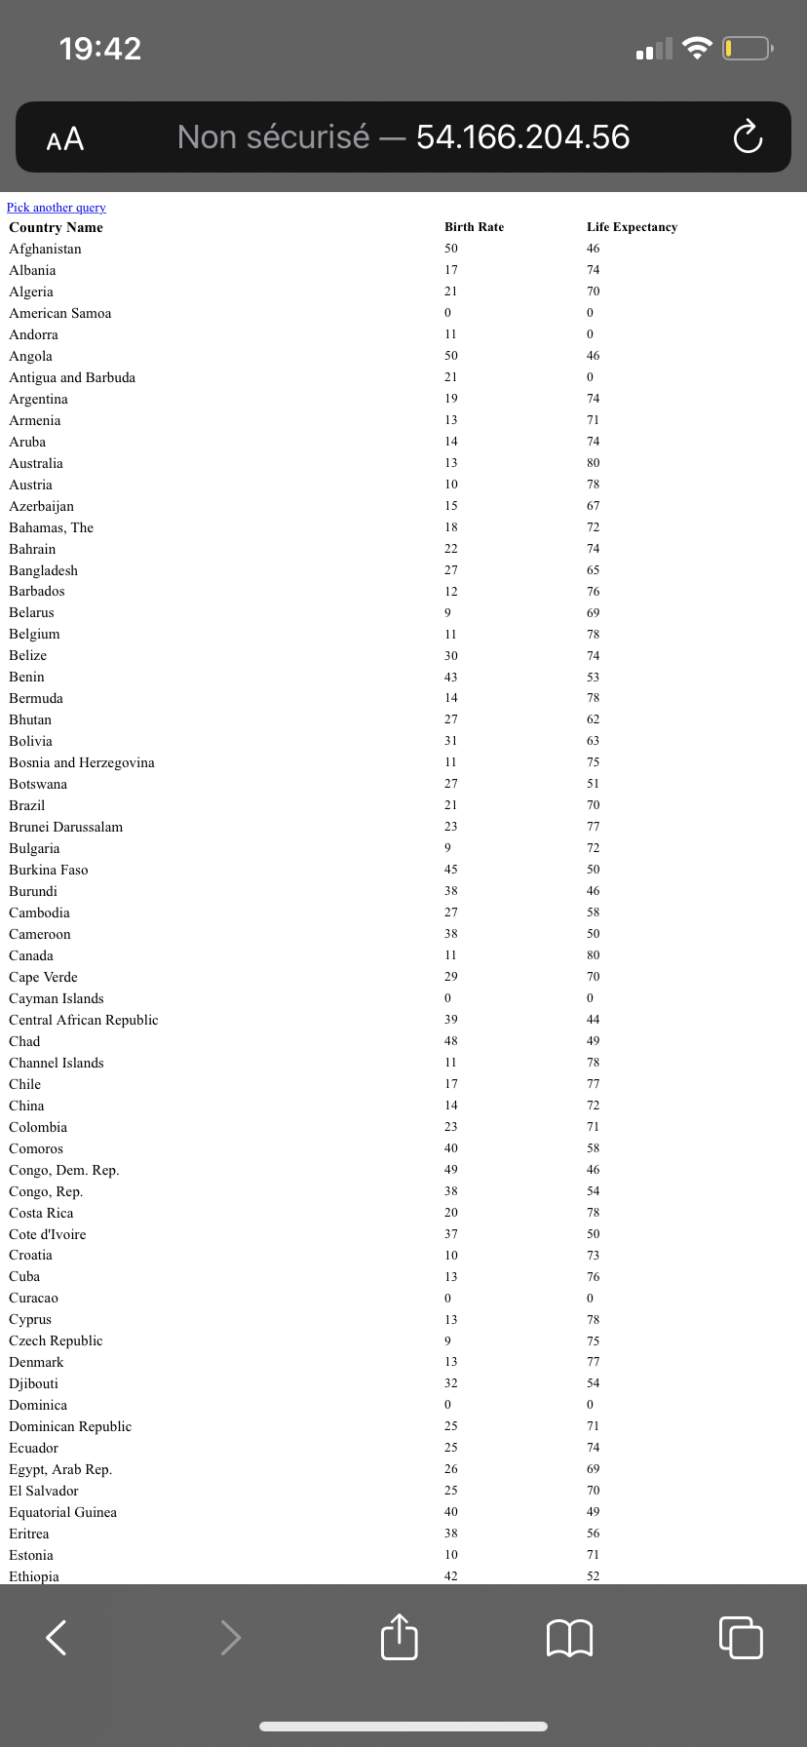

Query GDP:

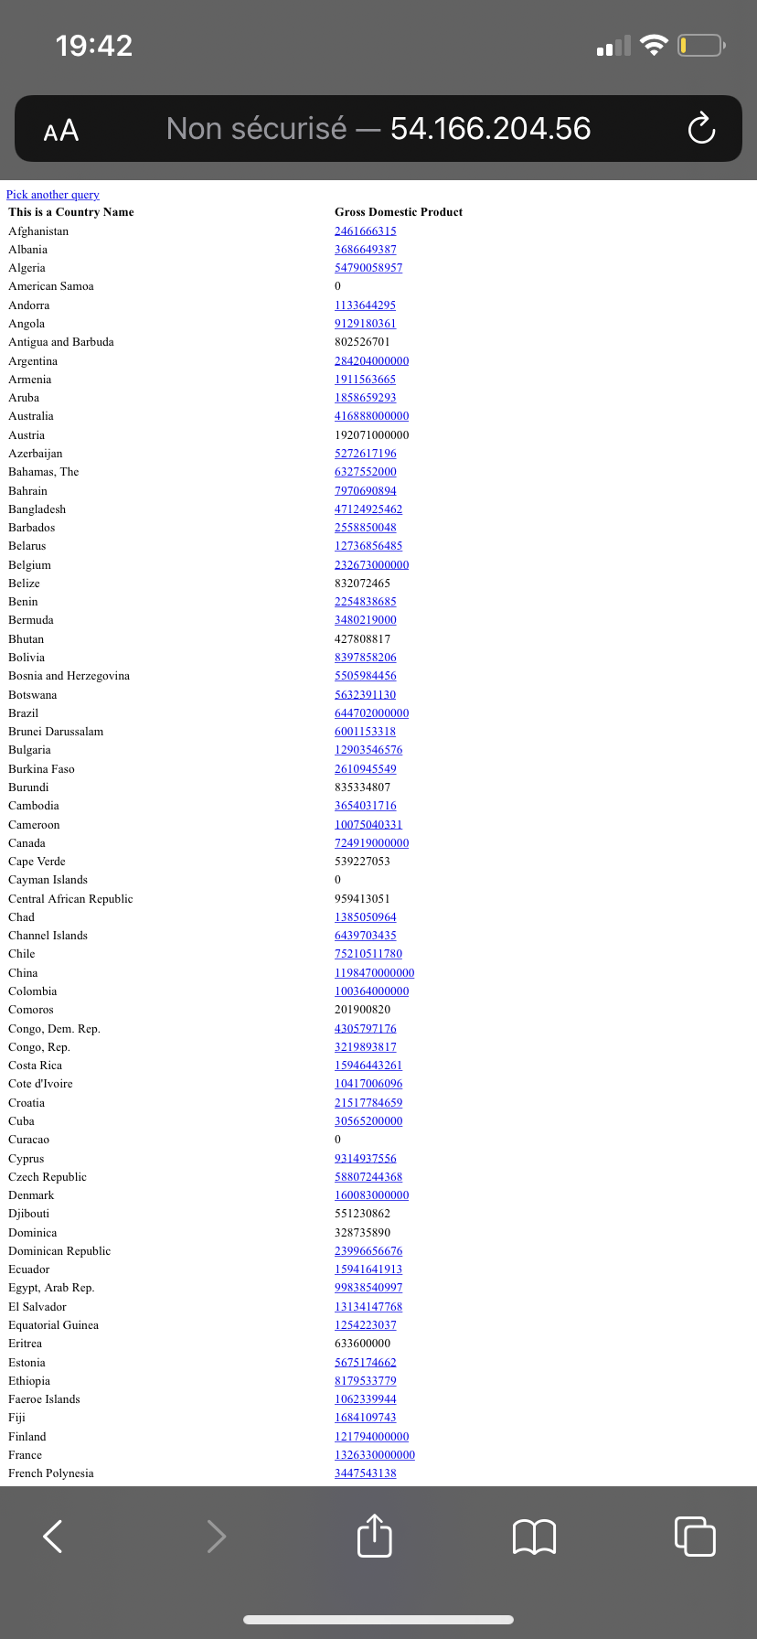

Query Childhood mortality:

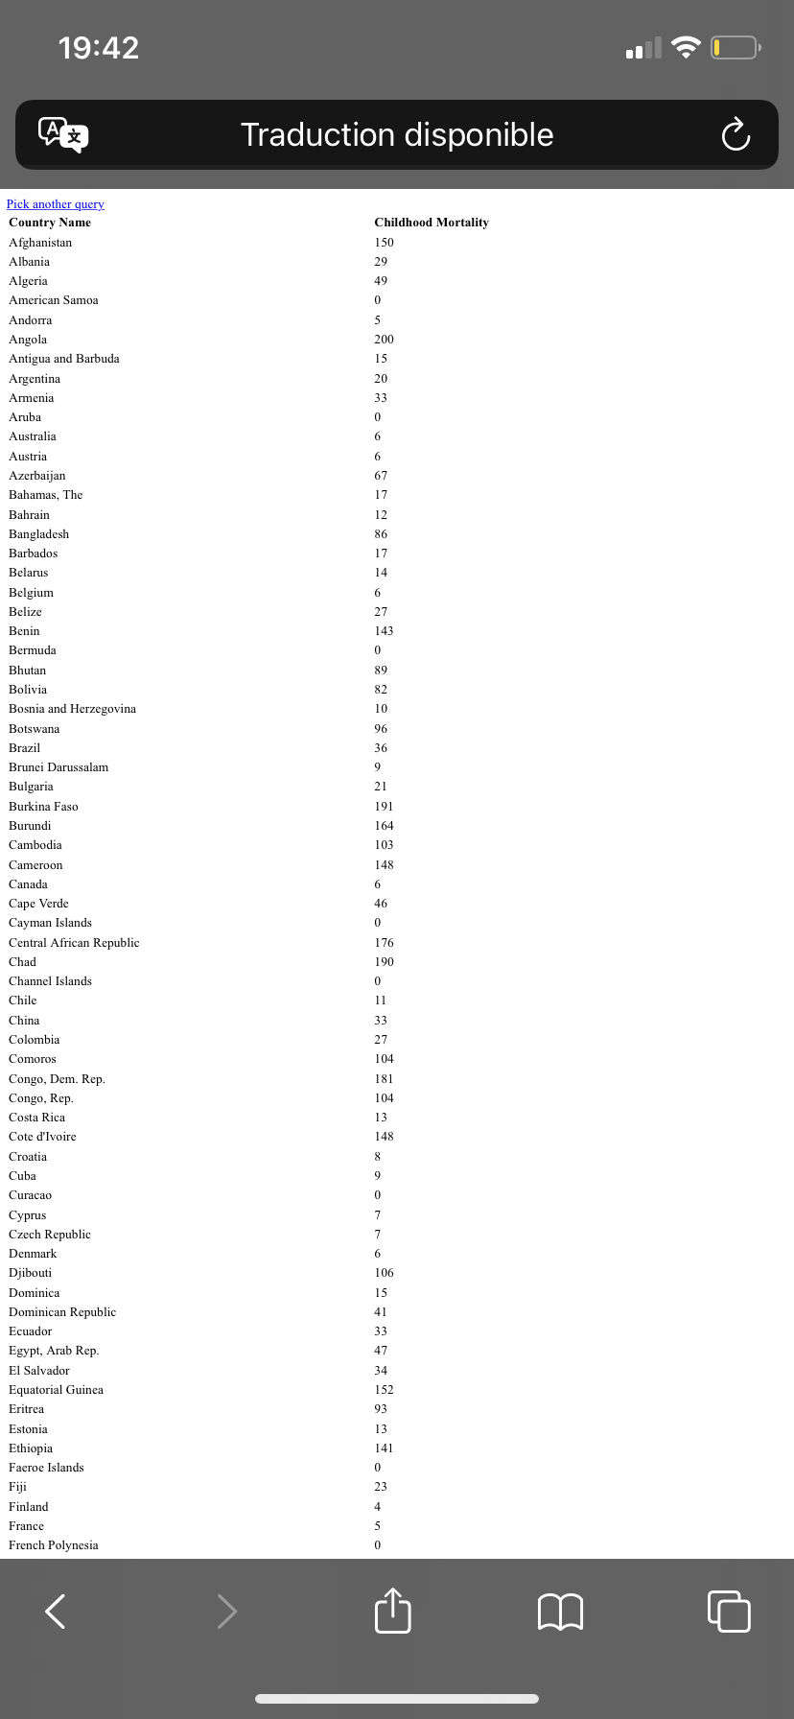

**SUMMARY**

To achieve a robust and secure website for the Example Social Research Organization, several design decisions were made during the implementation process. These decisions focused on improving performance, scalability, and security while leveraging the benefits of Amazon Web Services (AWS) infrastructure.

**Hosting on AWS:** The decision to host the website on AWS provides numerous benefits, including scalability, reliability, and a wide range of managed services to support the website's functionality and security requirements.

**Amazon EC2 Instances:** The website and MySQL database were migrated to Amazon EC2 instances. However, to improve security and performance, the design includes separating the web server and database server by utilizing separate EC2 instances. This ensures that the database is not directly exposed to the internet and reduces the attack surface.

**VPC and Subnets:** The website and database were deployed within an Amazon Virtual Private Cloud (VPC). This allows for better network isolation and control over inbound and outbound traffic. Public and private subnets were created within the VPC, with the web server placed in the public subnet for internet accessibility while the database server resides in the private subnet for enhanced security.

**Security Groups:** Security groups were employed to control inbound and outbound traffic for both the web server and the database server. By configuring appropriate security group rules, only necessary ports and protocols are allowed, reducing the risk of unauthorized access.

**Amazon RDS for MySQL:** To simplify database management and enhance security, the decision was made to migrate the MySQL database to Amazon RDS for MySQL. This managed service handles routine database tasks such as backups, software patching, and automatic scaling.

**IAM QUIZZ**

Question 1 : Which statement describes AWS Identity and Access Management (IAM) users ?

ANSWER : C/ Every IAM user for an account must have a unique name.

Question 2 : How can you grant the same level of permissions to multiple users within an account ?

ANSWER : A/ Apply an AWS Identity and Access Management (IAM) policy to an IAM group.

Question 3 : Which statements describe AWS Identity and Access Management (IAM) roles ? (Select TWO)

ANSWERS : C/ They can be assumed by individuals, applications, and services.

D/ They provide temporary security credentials.

Question 4 : Which statement describes a resource-based policy ?

ANSWER : A/ It can be applied to any AWS resource.

Question 5 : How does AWS Identity and Access Mangement (IAM) evaluate a policy ?

ANSWER : B/ It checks for explicit deny statements before it checks for explicit allow statements.

Question 6 : A team of developers needs access to several services and resources in a virtual private cloud (VPC) for 9 months. How can you use AWS Identity and Access Management (IAM) to enable access for them ?

ANSWER : C/ Create an IAM user for each developer, put them all in an IAM group, and attach the required IAM policies to the IAM group.

Question 7 : How does identity federation increase security for an application that is built in Amazon Web Services (AWS) ?

ANSWER : A/ Users can use single sign-on (SSO) to access the application through an existing authenticated identity.

**NETWORK QUIZZ**

Question 1 : Which definition describes a virtual private cloud (VPC) ?

ANSWER : C/ A logically isolated virtual network that you define in the AWS Cloud.

Question 2 : A company’s VPC has the CIDR block 172.16.0.0/21 (2048 addresses). It has two subnets (A and B). Each subnet must support 100 usable addresses now, but this number is expected to rise to at most 254 usable addresses soon. Which subnet addressing scheme meets the requirements and follows AWS best practices ?

ANSWER : C/ Subnet A : 172.16.0.0/23 (512 addresses) Subnet B : 172.16.2.0/23 (512 addresses)

Question 3 : Which combination of actions enables direct internet access for IPv4 hosts in a virtual private cloud (VPC) ? (Select THREE)

ANSWER : A/ Creating a route for 0.0.0.0/0 that points to the internet gateway. C/ Configuring hosts to have or obtain an internet-routable address. F/ Configuring security groups and network access control lists (network ACLs) to permit internet traffic.

Question 4 : Several EC2 instances launch in a virtual private cloud (VPC) that has internet access. These instances should not be accessible from the internet, but they must be able to download updates from the internet. How should the instances launch ?

ANSWER : D/ Without public IP addresses, in a subnet with a default route to a network address translation (NAT) gateway.

**IAM QUESTIONS**

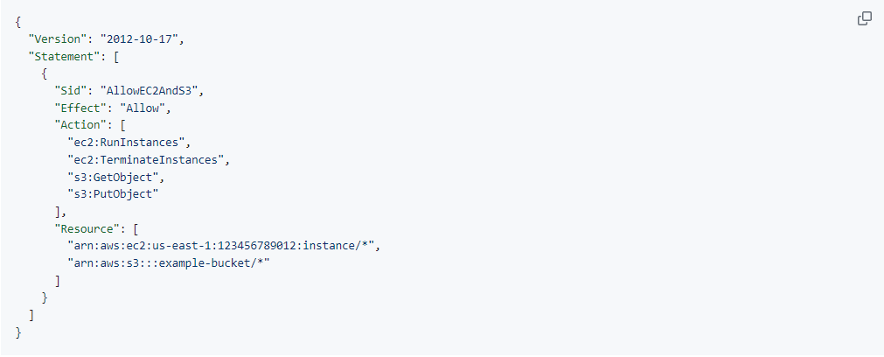

**What actions are allowed for EC2 instances and S3 objects based on this policy?**

For EC2 instances:

* ec2:RunInstances: Allowing the user to launch new instances.
* ec2:TerminateInstances: Allowing the user to terminate instances.

For S3 objects:

* s3:GetObject: Allowing the user to retrieve (get) objects from the S3 bucket.
* s3:PutObject: Allowing the user to upload (put) objects to the S3 bucket.

**What specific resources are included?**

* EC2 instances: All instances in the "us-east-1" region under the AWS account ID "123456789012" (specified by the ARN "arn:aws:ec2:us-east-1:123456789012:instance/*").
* S3 objects: All objects within the "example-bucket" S3 bucket (specified by the ARN "arn:aws:s3:::example-bucket/*").

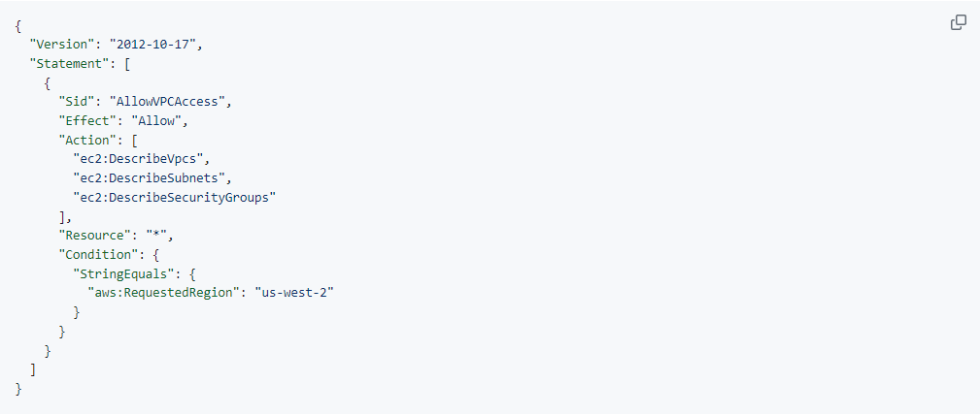

**Under what condition does this policy allow access to VPC-related information? Which AWS region is specified?**

The IAM policy provided allows access to VPC-related information under the condition that the requested AWS region is "us-west-2". The specified AWS region in the condition is "us-west-2".

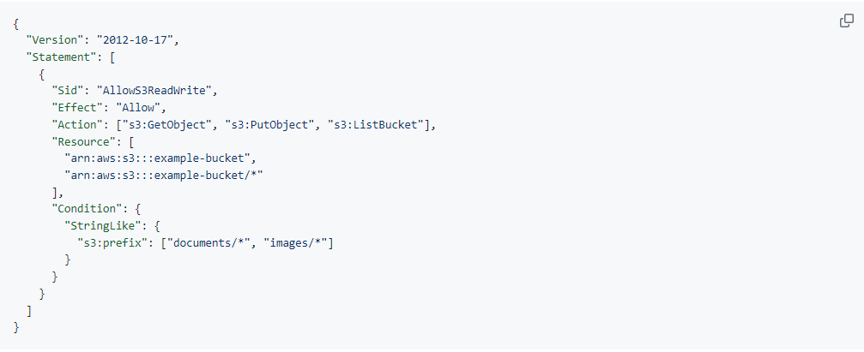

**What actions are allowed on the "example-bucket" and its objects based on this policy?**

* s3:GetObject: Allowing the user to retrieve (get) objects from the bucket.
* s3:PutObject: Allowing the user to upload (put) objects to the bucket.
* s3:ListBucket: Allowing the user to list the contents of the bucket.

**What specific prefixes are specified in the condition?**

* "documents/*": This allows access to objects within the "documents" prefix in the bucket.
* "images/*": This allows access to objects within the "images" prefix in the bucket.

So, the policy allows read and write actions on objects within the "example-bucket" with prefixes "documents/" and "images/".

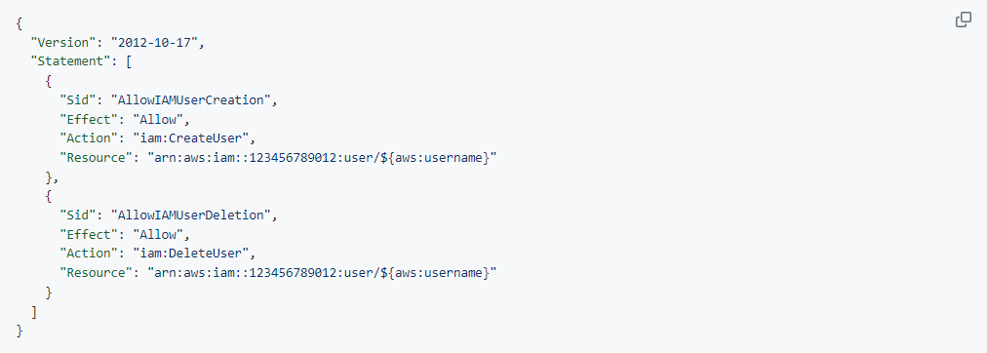

**What actions are allowed for IAM users based on this policy?**

* iam:CreateUser: Allowing the creation of IAM users.
* iam:DeleteUser: Allowing the deletion of IAM users.

**How are the resource ARNs constructed?**

The resource ARNs are constructed using the following format:

* "arn:aws:iam::123456789012:user/${aws:username}"

In the ARN, "123456789012" represents the AWS account ID, and "${aws:username}" is a variable that dynamically evaluates to the username of the IAM user. This allows the policy to be applied to the IAM user specified in the ARN, enabling the creation and deletion of IAM users for the specified AWS account.

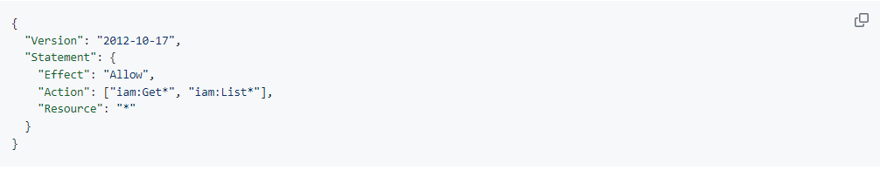

**Which AWS service does this policy grant you access to?**

It grants access to the Identity and Access Management (IAM) service.

**Does it allow you to create an IAM user, group, policy, or role?**

The policy allows you to retrieve information about IAM entities but does not explicitly grant permissions to create IAM users, groups, policies, or roles.

**Go to https://docs.aws.amazon.com/IAM/latest/UserGuide/ and in the left navigation expand Reference > Policy Reference > Actions, Resources, and Condition Keys. Choose Identity And Access Management. Scroll to the Actions Defined by Identity And Access Management list.��Name at least three specific actions that the iam:Get* action allows.**

* iam:GetUser: Retrieves information about an IAM user.
* iam:GetGroup: Retrieves information about an IAM group.
* iam:GetRole: Retrieves information about an IAM role.

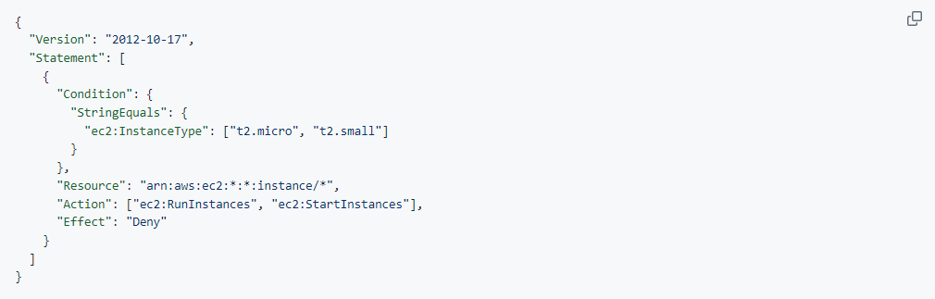

**What actions does the policy allow?**

The policy allows the "ec2:RunInstances" and "ec2:StartInstances" actions.

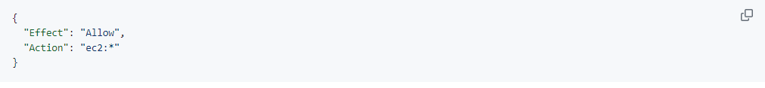

**How would the policy restrict the access granted to you by this additional statement?**

The additional statement would grant unrestricted access to all EC2 actions.

**If the policy included both the statement on the left and the statement in question 2, could you terminate an m3.xlarge instance that existed in the account?**

If the policy included both the original statement and the additional statement, allowing "ec2:RunInstances" and "ec2:StartInstances" but also granting unrestricted access to all EC2 actions, you would still be able to terminate an m3.xlarge instance. The policy only denies the "ec2:RunInstances" and "ec2:StartInstances" actions for the instance types "t2.micro" and "t2.small". Since the m3.xlarge instance is not covered by the condition in the Deny statement, you would be able to terminate it.

**ARCHITECTURE DIAGRAM**

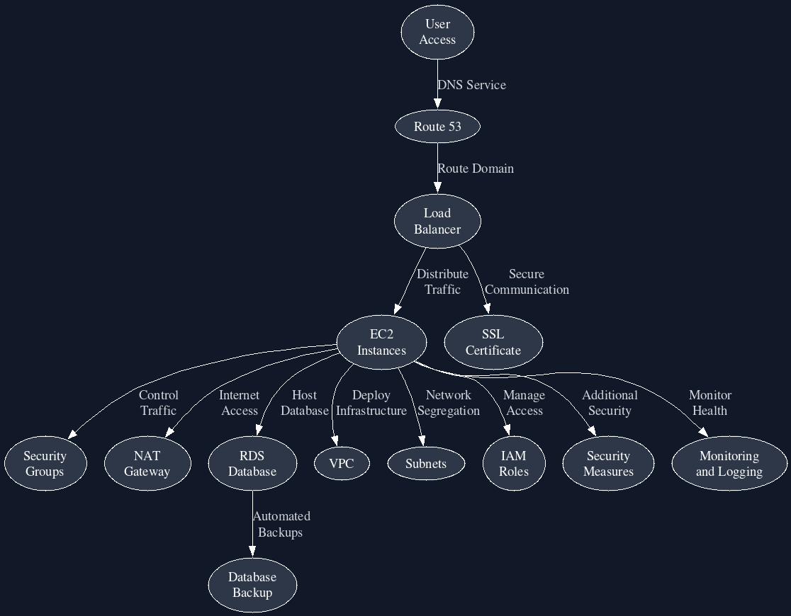

**Big Data - Data Visualization With AWS QuickSight**

Creating a New S3 Bucket

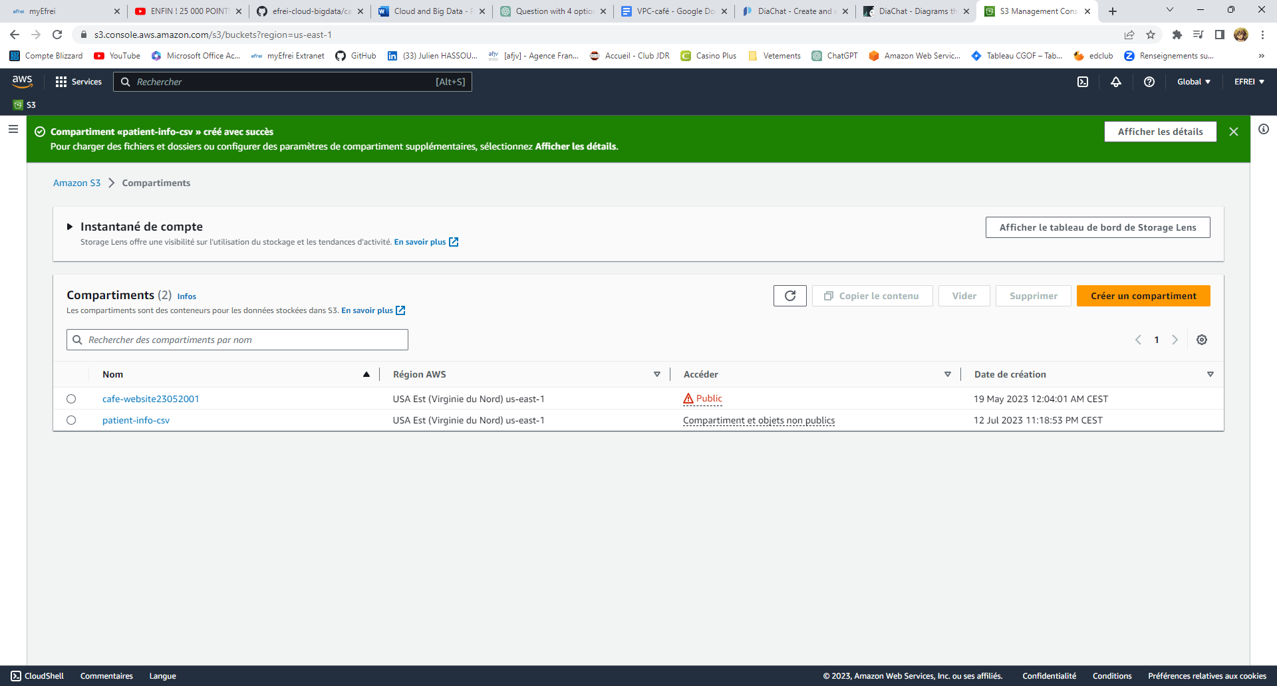

Uploading the Dataset to the S3 Bucket

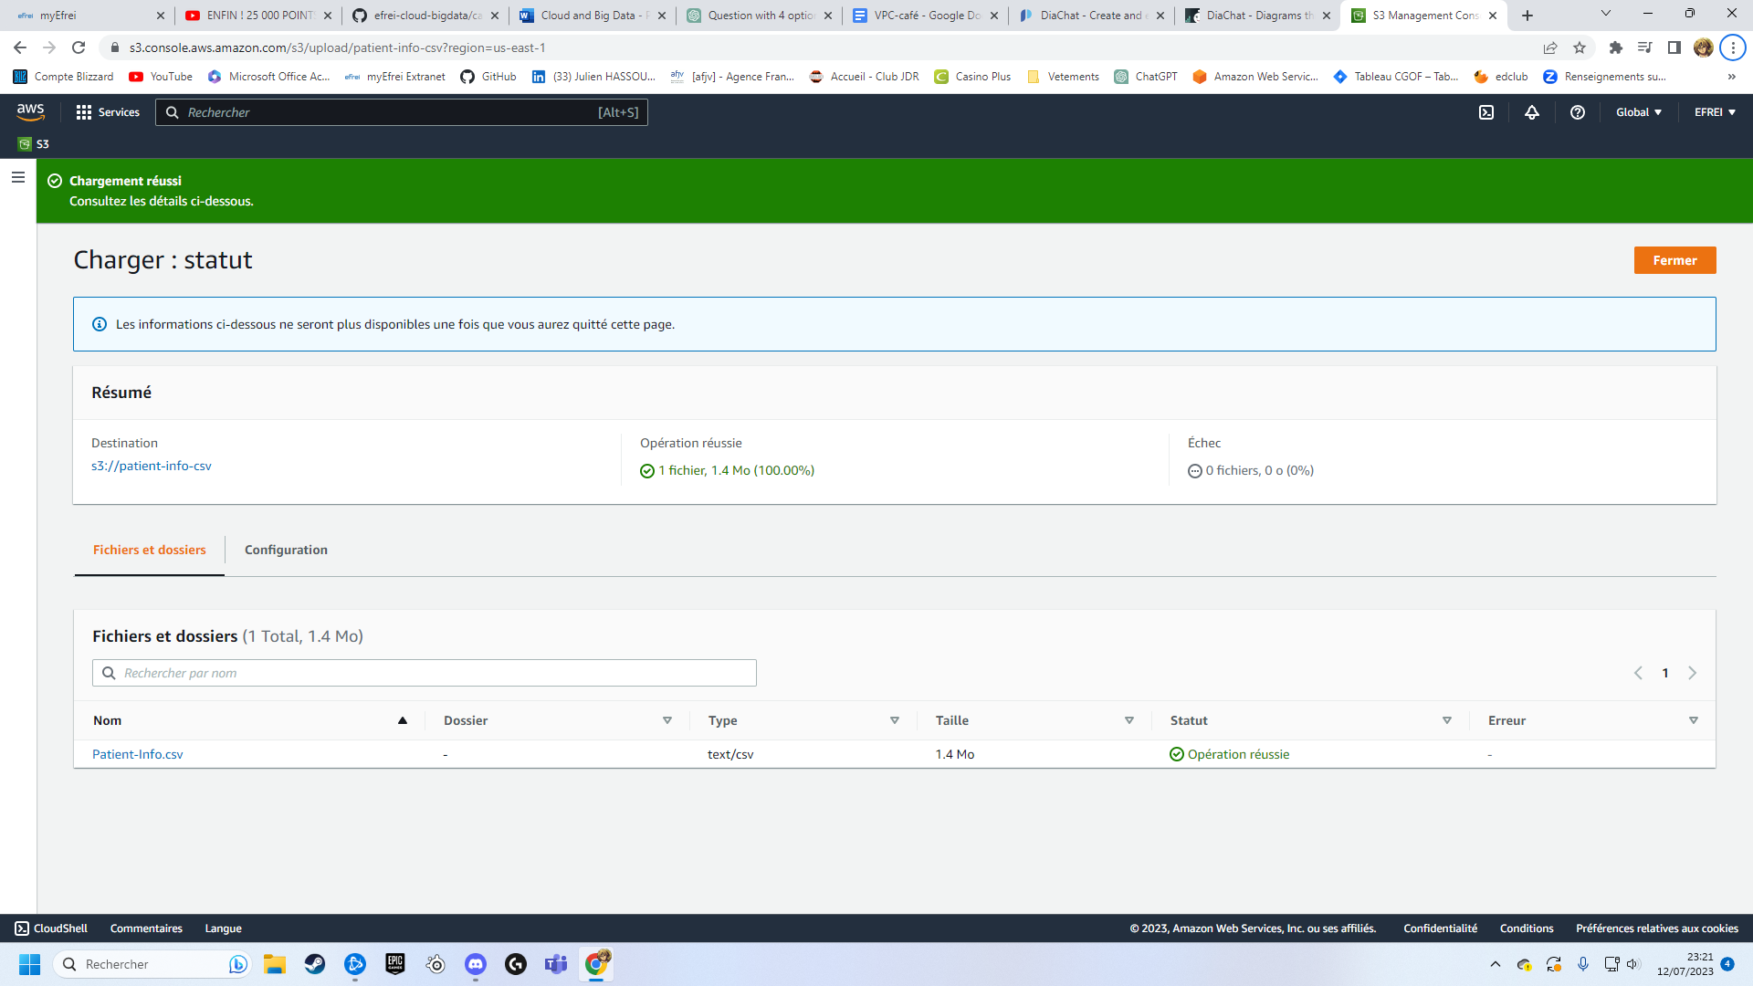

Connect QuickSight to the Dataset

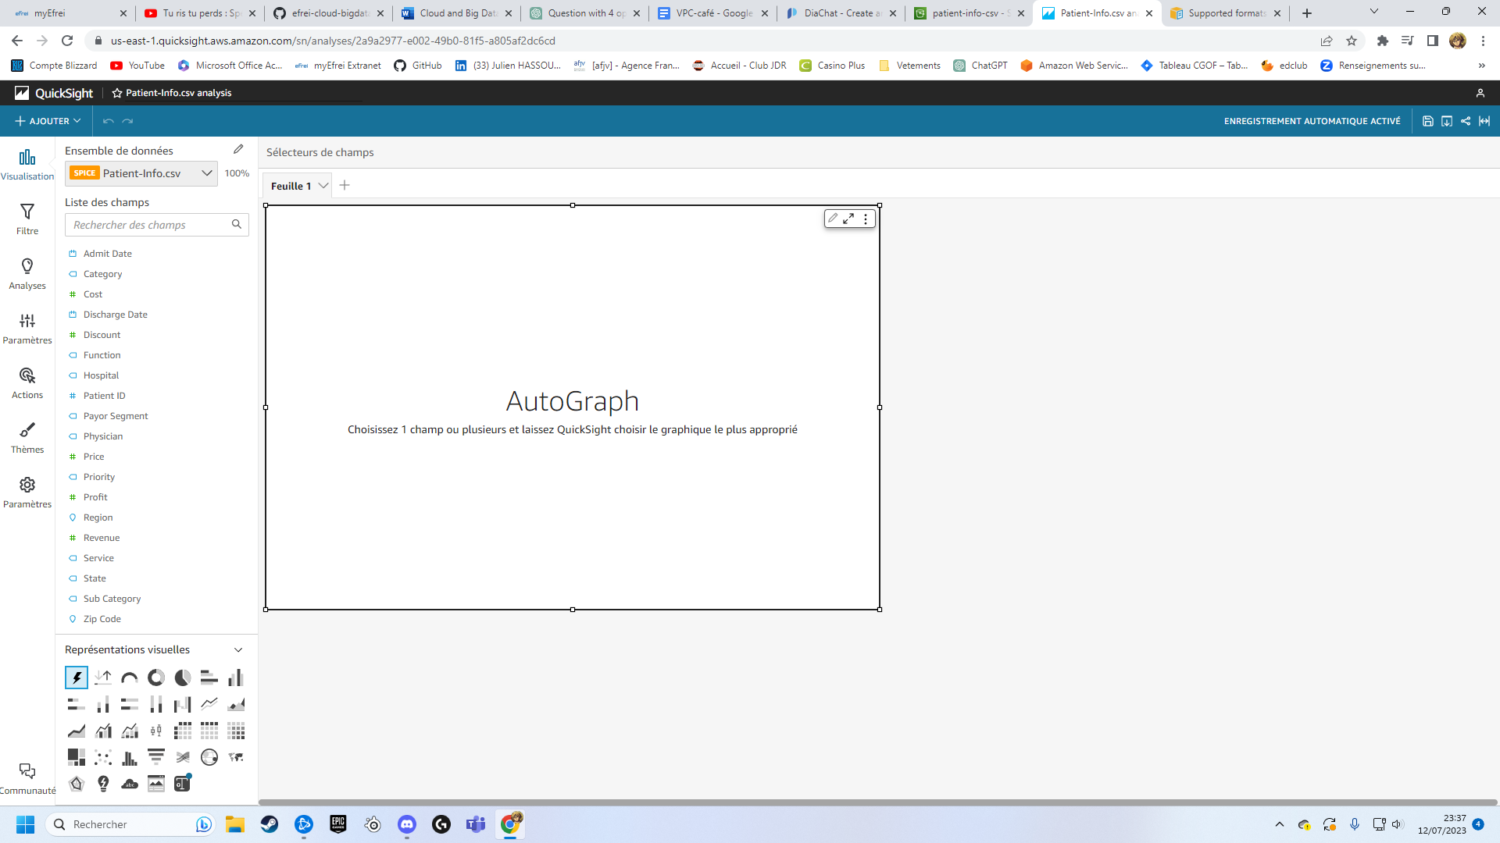

Build the Dashboard in QuickSight

